IT Project

Sales Data Analysis and Visualization for Retail Business Decision-Making

By

Varsha Reddy Gangasani

Submitted to:
Professor Jim Scott

Abstract
This project investigated how complex retail sales data could be analyzed using data analytics methodologies to support informed business decision-making. The study utilized the Superstore Sales Dataset, a publicly available retail sales dataset sourced from Kaggle, as the primary data source. Data analytics techniques were applied, including Exploratory Data Analysis (EDA), customer segmentation analysis, and RFM (Recency, Frequency, Monetary) analysis, to examine sales performance and profitability patterns across customer segments, product categories, and geographic regions. A live web-based prototype was developed using Python and Streamlit, enabling real-time sales analysis through dynamic filtering and automated business recommendations. A supplementary professional dashboard was constructed using Power BI to provide executive-level visual reporting. The findings revealed that the Consumer segment generated the highest total revenue at $1,161,401, while the Home Office segment achieved the highest profit margin at 14.0%. RFM analysis identified five distinct behavioral customer groups, including 193 Champion customers and 141 At-Risk customers who required immediate re-engagement. The prototype demonstrated that data visualization transformed raw retail sales data into actionable business intelligence, thereby supporting the conclusion that visualization significantly enhanced the speed and accuracy of retail business decision-making.

Keywords: Retail Analytics, Customer Segmentation, RFM Analysis, Data Visualization, Sales Performance, Business Intelligence, Streamlit, Power BI

Table of Contents
Abstract 2
List of Figures 5
List of Tables 5
1. Introduction 6
1.1 Background and Context 6
1.2 Problem Statement 6
1.3 Project Objectives and Research Questions 7
1.4 Significance and Motivation 7
1.5 Literature Review and Research Gaps 8
1.6 Methodology and Approach 8
1.7 Structure of the Paper 8
2. Literature Review 9
2.1 Overview of Customer Segmentation in Retail Analytics 9
2.2 RFM Analysis as a Segmentation Framework 9
2.3 The Role of Data Visualization in Business Decision-Making 9
2.4 Sales Trend Analysis and Temporal Patterns 10
2.5 Discount Strategy and Profit Impact 10
2.6 Interactive Prototypes as Research Deliverables 10
2.7 Research Gaps Addressed by This Project 10
3. Methodology 12
3.1 Research Design 12
3.2 Data Acquisition 12
3.3 Data Preprocessing 13
3.4 Data Visualization and Prototype Development 14
3.5 Power BI Dashboard 22
3.6 Technology Stack 23
4. Results and Discussion 24
4.1 Summary of Findings 24
4.2 Explanation of Results — Customer Segmentation (RQ1 & RQ3) 24
4.3 RFM Behavioral Segmentation (RQ2) 25
4.4 Sales Trend and Discount Analysis 25
4.5 Addressing Research Questions 26
4.6 Implications and Significance 26
5. Conclusion and Future Work 28
5.1 Limitations 28
References 30

List of Figures
Figure 1: Six-Stage Research and Development Pipeline 12
Figure 2: Dataset Overview — Key Characteristics 13
Figure 3: RFM Scoring Framework 14
Figure 4: Streamlit App — Overview Tab (KPI Cards and Charts) 15
Figure 5: Streamlit App — Customer Segmentation Tab 16
Figure 6: Streamlit App — Sales Trends Tab 17
Figure 7: Streamlit App — RFM Analysis Tab 18
Figure 8: Streamlit App — Visualization Impact Tab 20
Figure 9: Streamlit App — Recommendations Tab 22
Figure 10: Power BI Dashboard 23
Figure 11: Technology Stack 23

List of Tables
Table 0: Full Dataset Key Performance Indicators. 24
Table 1: Sales and Profit Metrics by Customer Segment 24
Table 2: RFM Behavioral Segmentation Summary 25
Table 3: Purchase Frequency and Order Value by Segment 25
Table 4: Sub-Category Performance Summary 26

1. Introduction

1.1 Background and Context
Every day, retailers create enormous amounts of transaction data, yet many companies find themselves unable to derive actionable insight because they lack a structured analytical methodology for developing reports. Research confirms that organizations with structured data analytics capabilities are significantly more likely to outperform peers in revenue growth and customer retention [1]
In today's data-driven business environment, understanding customer behavior, recognizing the most profitable groups, and visualizing sales patterns help create competitive advantages. Traditional reporting methods such as static spreadsheets are no longer capable of delivering the speed, accuracy, and reliability necessary for timely data-driven decisions across multiple product categories, geographic regions, and customer segments [2]
Data analytic and visualization technologies such as Python, with libraries like Pandas and Plotly, and business intelligence tools like Power BI, allow even small retailers to perform complex sales analytics. Customer segmentation methods such as RFM analysis make it possible for businesses to classify customers into distinct groups based on purchasing behavior, enabling more targeted marketing, better inventory planning, and improved customer retention [3]
This project responded to the growing need for accessible, reusable analytics tools in the retail sector by developing an interactive web-based dashboard that transforms raw sales data into clear, visual, and actionable business intelligence.

1.2 Problem Statement
Retailers frequently gather substantial amounts of transaction-related data; however, they often lack the analytical frameworks and tools to extract useful business intelligence. As a result, many retailers miss opportunities to retain customers, make poor resource allocation decisions, and apply incorrect pricing or discount strategies [4]
The core challenge this project addressed was converting raw sales data into usable, visual representations that retail decision-makers can understand and act upon without extensive technical experience. Studies in business intelligence confirm that the inability to translate raw transactional data into visual decision-support tools is one of the primary barriers to data-driven decision-making in small and mid-sized retail organizations [5]
As a solution, this project proposed a working interactive prototype — an automated system for converting a retailer's sales data into segmented analysis, trend visualizations, and business recommendations within minutes of uploading their data files.

1.3 Project Objectives and Research Questions
The primary objective of this project was to design, develop, and demonstrate a reusable interactive analytics prototype that enables retail businesses to analyze customer segmentation, sales trends, and profit patterns through data visualization. This aligns with design science research principles that emphasize the development of functional artifacts solving identified organizational problems [6]
The following research questions guided this project:
- RQ1: How does customer segmentation impact sales performance and profitability in a retail business?
- RQ2: What distinct customer segments can be identified using retail sales data?
- RQ3: How do sales metrics such as revenue, frequency of purchase, and profit vary across customer segments?
- RQ4 (Main): How can data visualization improve the interpretation of segmented sales insights for business decision-making?

1.4 Significance and Motivation
One of the most significant advantages any retail company can develop is a structured understanding of its customer segments. When companies determine which customer groups generate the highest revenues and which are at the greatest risk of churn, they can allocate marketing resources more strategically, create targeted promotions, and enhance customer lifetime value. Research demonstrates that businesses employing customer segmentation strategies achieve measurably higher marketing ROI and customer retention rates than those relying on undifferentiated approaches [7]
The creation of an interactive prototype instead of a purely static analysis was driven by the requirement that the deliverable be reusable. The prototype developed as part of this project allows any retail business to upload its own CSV dataset and obtain automated analysis with no programming knowledge required, making it immediately applicable in a real-world retail environment.

1.5 Literature Review and Research Gaps
Previous investigation within the field of retail analytics has thoroughly covered customer segmentation approaches such as RFM analysis, K-Means clustering, and behavior profiling, demonstrating that implementing these methods leads to improved customer retention and increased marketing ROI [8]
However, a significant gap exists in the literature regarding the development of accessible, interactive tools that bring these analytical capabilities directly to business users without requiring data science expertise. Additionally, there are numerous studies that provide static analysis outputs, but very few provide systems that can be reused with different datasets and configurations. This project was designed to address both gaps [9]

1.6 Methodology and Approach
An applied research design with a quantitative approach was used for this project. The methodology began with data collection from an open-source retail dataset from Kaggle, followed by data cleaning and preparation in Python, and exploratory data analysis (EDA) to identify sales, profit, and customer behavior patterns across segments, regions, and product categories. Customer segmentation was conducted at two levels: predefined business segments (Consumer, Corporate, and Home Office) and behavioral segments created through RFM scoring. An interactive prototype was built using the Streamlit web framework, comprising six functional tabs. A supplementary Power BI dashboard was developed for professional visual reporting.

1.7 Structure of the Paper
The remainder of this paper is organized as follows. Section 2 presents a review of the relevant literature on customer segmentation, data visualization, and retail analytics. Section 3 describes the methodology, covering data collection, cleaning, feature engineering, and the design of the prototype. Section 4 presents the results and discusses the key findings in relation to each research question. Section 5 concludes the study and outlines directions for future work. References are listed at the end of the paper.

2. Literature Review

2.1 Overview of Customer Segmentation in Retail Analytics
Customer segmentation is a critical component of retail marketing, as it provides insight into customer needs and preferences. Companies can segment customers into groups that share similar traits such as demographic data, geographic location, and purchasing behaviors. Studies show that when businesses employ segmentation techniques, they achieve higher levels of marketing efficiency, greater customer satisfaction, and stronger financial performance [1]
The growing number of analytics solutions on the market has allowed more retail organizations to conduct complex segmentation analyses at larger scales. Advanced analytics solutions allow companies to process large volumes of transaction-level data, identifying buying behavior that would have been invisible when evaluated solely from aggregate-level reports [2]
This study leveraged a combination of traditional defined segment-related analyses and behaviorally correlated analyses through RFM scoring to conduct a comprehensive customer segment analysis.

2.2 RFM Analysis as a Segmentation Framework
RFM analysis is one of the most extensively used and empirically validated techniques for customer segmentation in retailing. The three dimensions of customer evaluation are Recency (when they last purchased), Frequency (number of purchases), and Monetary value (total amount spent). Research has found strong correlations between RFM scores and customer loyalty, churn risk, and lifetime value [3]
By combining these three dimensions into one composite score, businesses can develop actionable customer segments such as Champions, Loyal Customers, At-Risk, and Lost Customers. The major advantage of RFM analysis over machine learning-based segmentation techniques is that the segments are much easier for non-technical business users to interpret and act upon without requiring knowledge of underlying statistical methods [4]

2.3 The Role of Data Visualization in Business Decision-Making
Recent research suggests that data visualization is becoming increasingly important for enabling evidence-based decision-making in organizations. Research in human-computer interaction and business intelligence has shown that displaying data visually allows people to identify patterns and anomalies significantly more quickly compared to using raw data tables [5]
Studies evaluating the use of Power BI and Tableau found that interactive dashboard users make decisions faster and more accurately than traditional report users. This evidence directly supports the main research question explored in this project: whether data visualization improves the interpretation of segmented sales insights for retail decision-making [6]

2.4 Sales Trend Analysis and Temporal Patterns
Retail sales data exhibits strong temporal patterns including seasonal peaks, promotional effects, and long-term revenue trends. Time-series analysis has been applied extensively to decompose these behaviors and support forecasting. Research shows that analysis of sales trends over monthly and yearly time horizons is important for detecting periods of poor performance and tracking the effect of business decisions on revenue [7]

2.5 Discount Strategy and Profit Impact
The most disputed issue within retail analytics concerns the relationship between discounting strategy and profit. Research has shown that while discounts increase short-term sales volume, excessive discounting erodes profit margins and diminishes the perceived value of retail brands. The ability to quantify the profit impact of various discount levels is therefore critical to retail management [8]

2.6 Interactive Prototypes as Research Deliverables
A growing body of applied research in information systems emphasizes the value of working prototypes as research contributions. Unlike purely analytical studies, interactive prototypes demonstrate the practical feasibility of proposed solutions and allow stakeholders to directly evaluate their utility. In retail analytics, tools that allow users to upload their own data and receive automated insights represent a significant advance over paper-based analytical frameworks [9]

2.7 Research Gaps Addressed by This Project
Several research gaps related to customer segmentation and retail analytics remained despite the number of published studies in these areas. First, the majority of published studies presented static analyses of specific datasets rather than reusable tools applicable across different retail contexts. Second, limited evidence demonstrated the comparative value of visual versus raw data representations for business decision-making. Third, relatively little research addressed the integration of multiple segmentation techniques within a single interactive interface. This project was designed to address all three gaps through the development of a reusable, multi-method, interactive analytics prototype.

3. Methodology

3.1 Research Design
This project adopted a quantitative, applied research design consistent with the goal of developing and evaluating a data-driven analytics prototype. Quantitative research methods are appropriate when the objective is to identify measurable patterns across structured numerical data, particularly in retail analytics contexts where transactional records form the primary evidence base [1]
The applied design reflects the focus on creating a functional prototype rather than a purely theoretical contribution, which aligns with design science research principles that emphasize the development of artifacts solving real organizational problems [6]
The research followed a six-stage pipeline as shown in Figure 1 below: data collection, data cleaning and preparation, exploratory data analysis, customer segmentation, prototype creation, and dashboard construction. Each stage built directly on the previous, ensuring analytically derived outputs were grounded in cleaned and validated data.

Figure 1: Six-Stage Research and Development Pipeline
Step 1 | Step 2 | Step 3 | Step 4 | Step 5 | Step 6
Data Collection (Kaggle) | Data Cleaning (Python) | EDA & Analysis | RFM Segmentation | Streamlit Prototype | Power BI Dashboard
Figure 1: Six-Stage Research and Development Pipeline

3.2 Data Acquisition
The dataset used in this study was the Sample Superstore Sales Dataset, a publicly available retail transactions dataset obtained from Kaggle. Kaggle is a widely recognized platform for academic and research datasets, commonly used in data analytics and machine learning studies due to its curated, high-quality public datasets [10]

Vivek, R. (2021). Superstore Dataset. Kaggle. Retrieved from https://www.kaggle.com/datasets/vivek468/superstore-dataset-final

The dataset contained 9,994 transactional records spanning four years (2014 to 2018) and covered retail sales across the United States. It included 21 variables capturing order details, customer information, product categories, and financial metrics. Figure 2 summarizes the key characteristics of the dataset.

Figure 2: Dataset Overview
Total Records | Time Period | Unique Customers | Regions
9,994 | 2014 – 2017 | 793 | 4 (E, W, C, S)
Product Categories | Sub-Categories | Business Segments | Total Revenue
3 | 17 | 3 | $2,297,201
Figure 2: Dataset Key Characteristics — Superstore Sales Dataset (Kaggle, 2021)

3.3 Data Preprocessing

3.3.1 Missing Values and Data Quality
Upon initial examination of the dataset, no missing values were present across all 21 columns. Duplicate records were also checked and none were found, confirming the integrity of the raw data. Date columns (Order Date and Ship Date) were converted from string format to proper datetime objects to enable temporal analysis.

3.3.2 Feature Engineering
Several derived features were created to enrich the analytical dataset. A Year column was extracted from Order Date to enable annual filtering and comparison. A Month column was created in period format to support monthly trend analysis. A Profit Margin field was calculated as (Profit / Sales) x 100, providing a normalized measure of profitability. Feature engineering of this kind is a well-established practice in retail analytics that enhances the interpretability and predictive power of derived models [5]

3.3.3 RFM Feature Derivation
For the RFM analysis, three behavioral metrics were derived at the customer level from the transaction history. Recency was calculated as the number of days between each customer's most recent purchase and a snapshot date one day after the latest order in the dataset. Frequency was measured as the count of distinct orders placed by each customer. Monetary value was the total sales revenue attributed to each customer. Each metric was scored 1–4 using quartile-based binning, and the three scores were summed to produce a composite RFM score ranging from 3–12. This quartile-based RFM scoring methodology is consistent with widely published retail segmentation practice [3]

Figure 3: RFM Scoring Framework
RFM Dimension | Measurement | Score Range
Recency (R) | Days since last purchase | 1 (oldest) → 4 (most recent)
Frequency (F) | Count of distinct orders placed | 1 (lowest) → 4 (highest)
Monetary (M) | Total sales revenue | 1 (lowest) → 4 (highest)
Composite Score | R + F + M | 3 (lowest) → 12 (highest)
Figure 3: RFM Scoring Framework — Dimensions, Measurement, and Score Ranges

3.4 Data Visualization and Prototype Development
The interactive analytics prototype was developed using Python and the Streamlit web application framework. Streamlit was selected for its ability to convert Python data analysis scripts into deployable web applications with minimal additional code, making it well-suited to applied research prototyping contexts where rapid development and demonstrability are both required [9]
The prototype was organized into six functional tabs, each addressing one or more of the four research questions. The tab structure is described below:

Tab 1 — Overview: Presents four KPI cards displaying Total Sales ($2,297,201), Total Orders (5,009), Total Profit ($286,397), and Total Customers (793). Two charts provide a high-level summary: a bar chart of sales by product category and a pie chart of sales distribution by region. Figure 5 shows a screenshot of this tab.
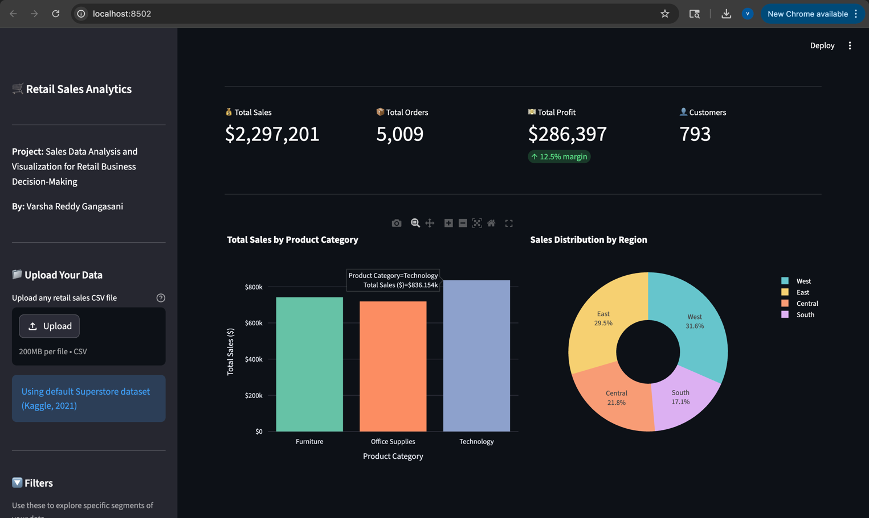
Figure 5: Streamlit App — Overview Tab (KPI Cards and Charts)
Tab 2 — Customer Segmentation: Addresses RQ1 and RQ3. A summary table displays Total Sales, Total Profit, Profit Margin, Total Orders, Average Orders per Customer, Average Order Value, and Unique Customers for each segment. Four charts visualize segment performance. Figure 6 shows this tab.
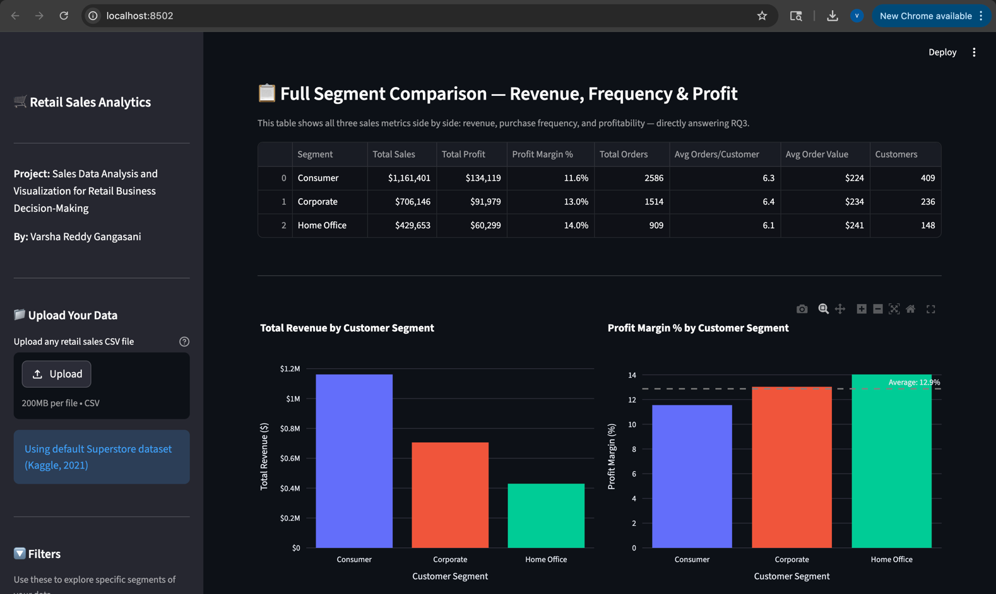
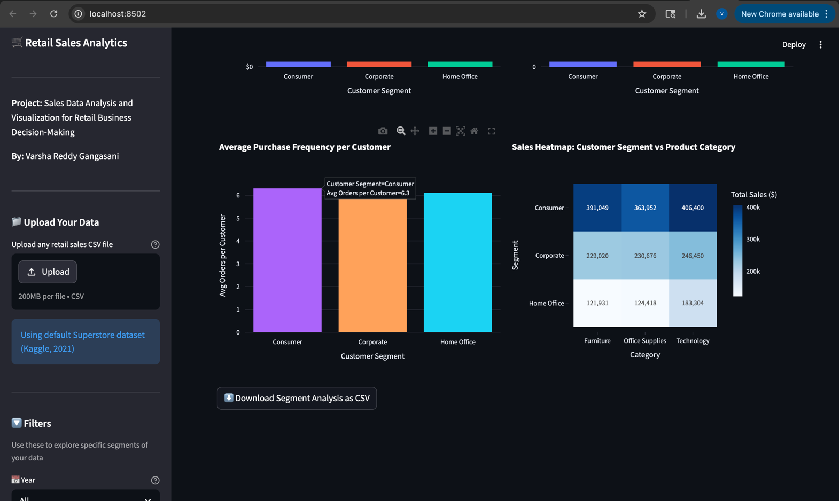
Figure 6: Streamlit App — Customer Segmentation Tab
Tab 3 — Sales Trends: A monthly line chart compared Sales and Profit trends over the full four-year period. A horizontal bar chart identified the top ten sub-categories by total sales. A scatter plot with an OLS trend line visualized the relationship between discount rates and average profit.
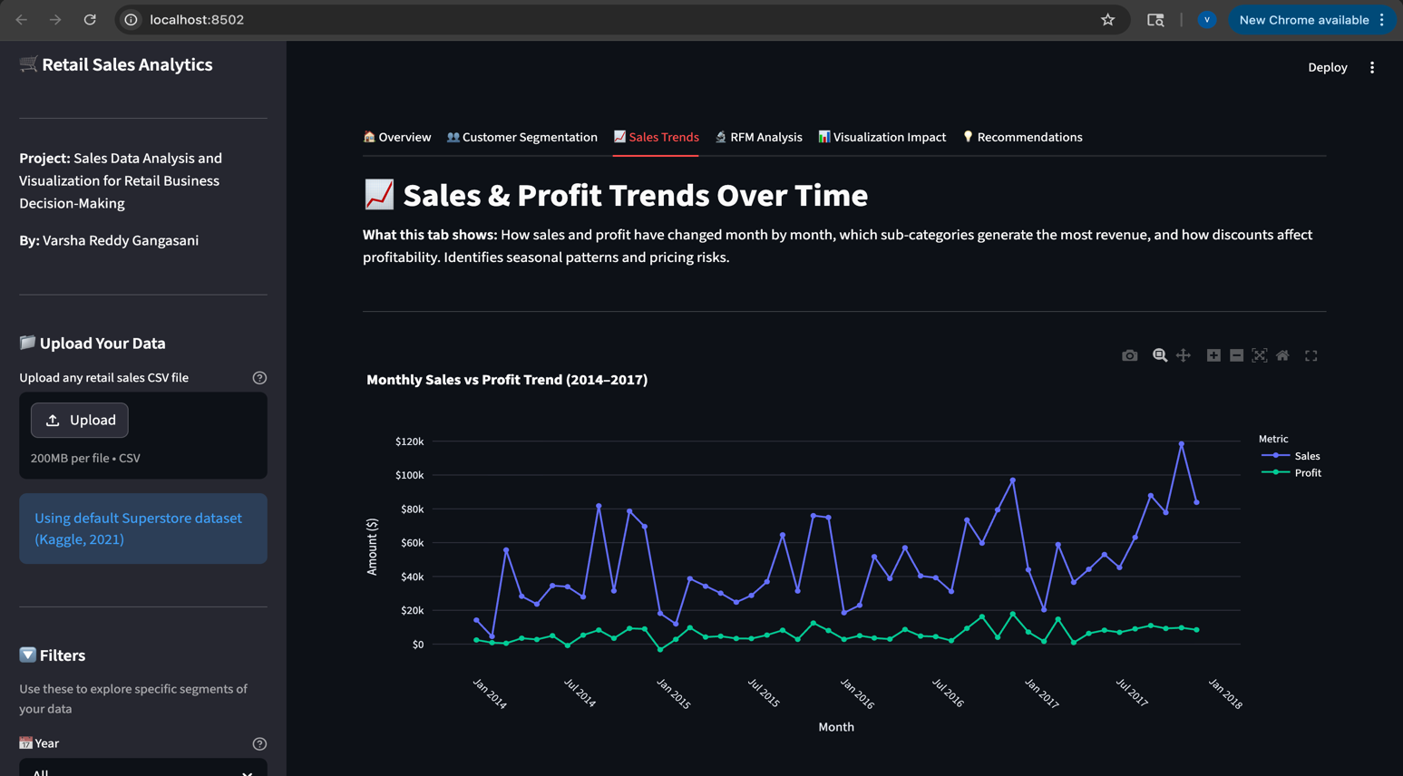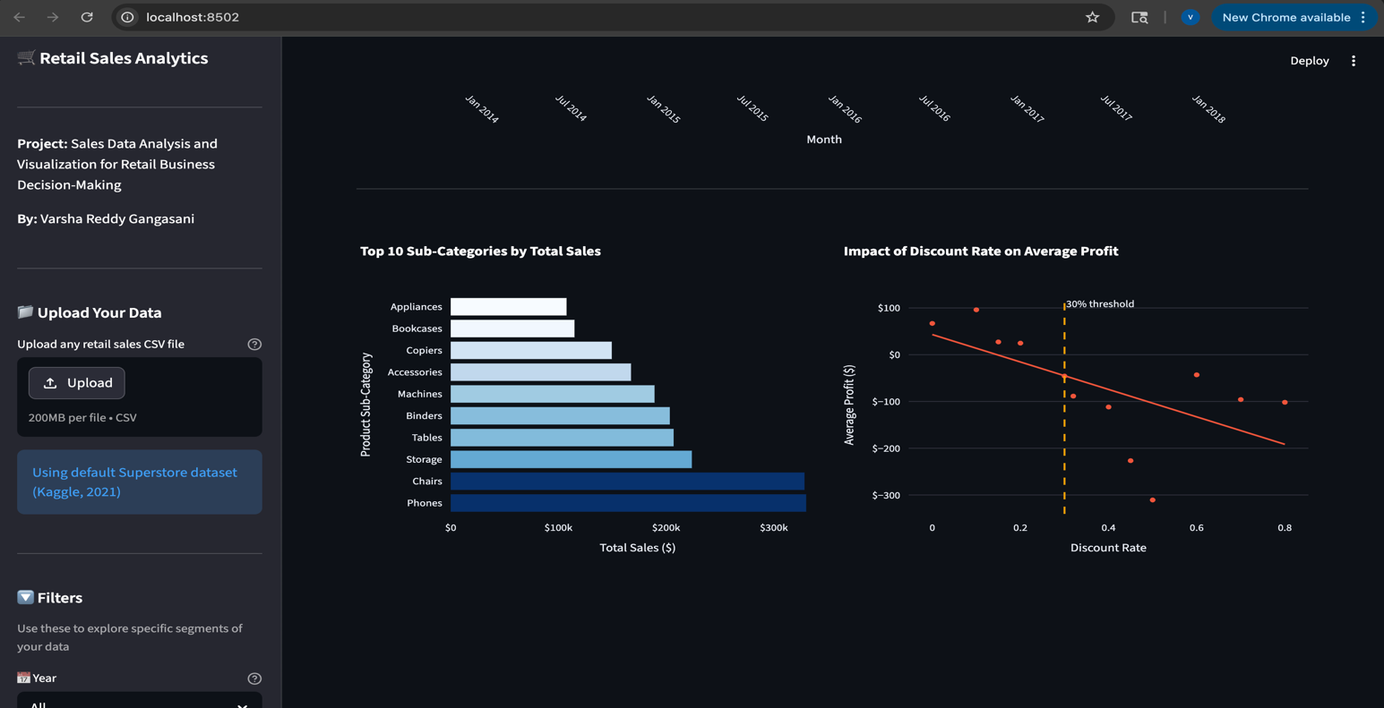
Figure 7: Streamlit App- Sales Trend Tab (Monthly trend Line Chart)
Tab 4 — RFM Analysis: Addresses RQ2 through behavioral segmentation of all 793 customers. The tab displayed a pie chart of customer distribution by RFM segment, bar charts of average spending and purchase frequency per segment, and a scatter plot of Frequency versus Monetary value.
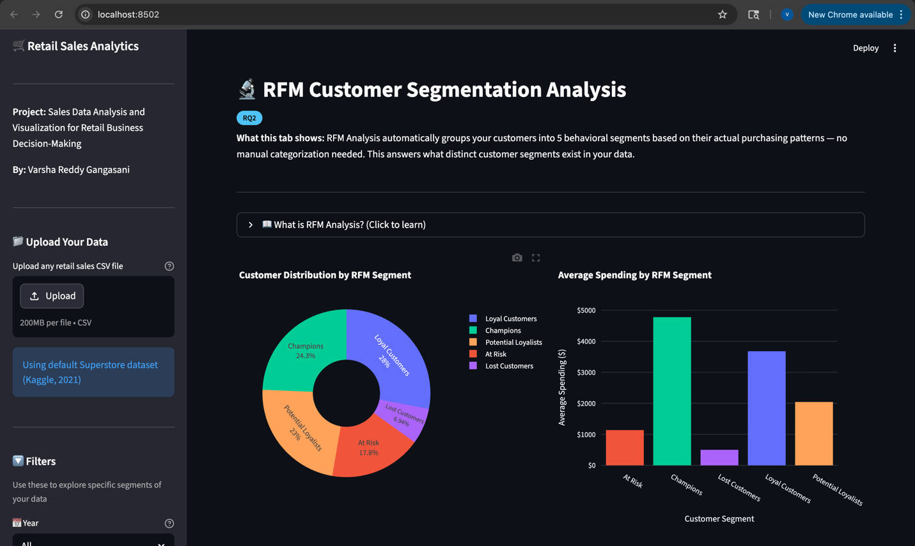
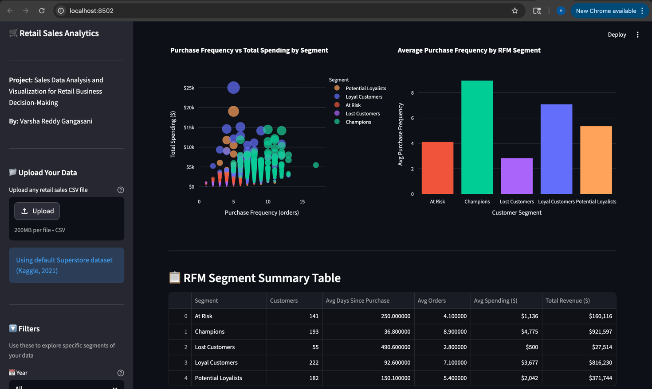
Figure 8: Streamlit App — RFM Analysis Tab
Tab 5 — Visualization Impact: Directly addresses RQ4. It presented the same data in two formats side-by-side: a raw data table and a set of interactive charts, demonstrating how visualization accelerates pattern recognition.
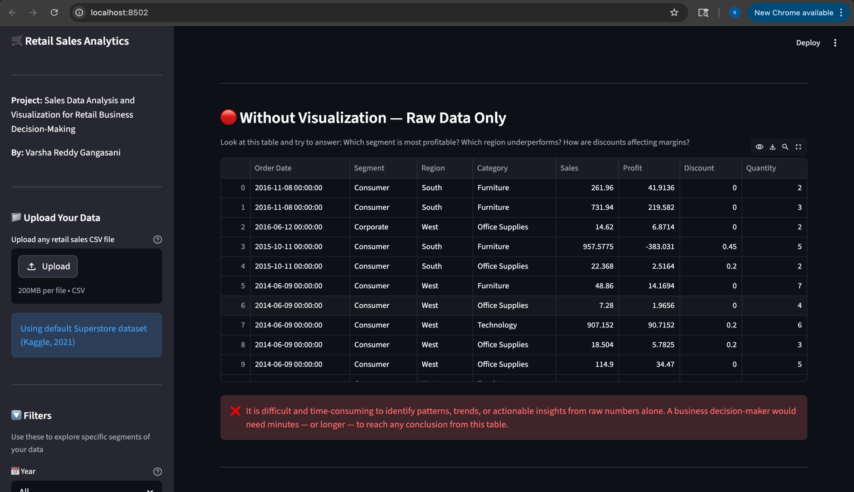
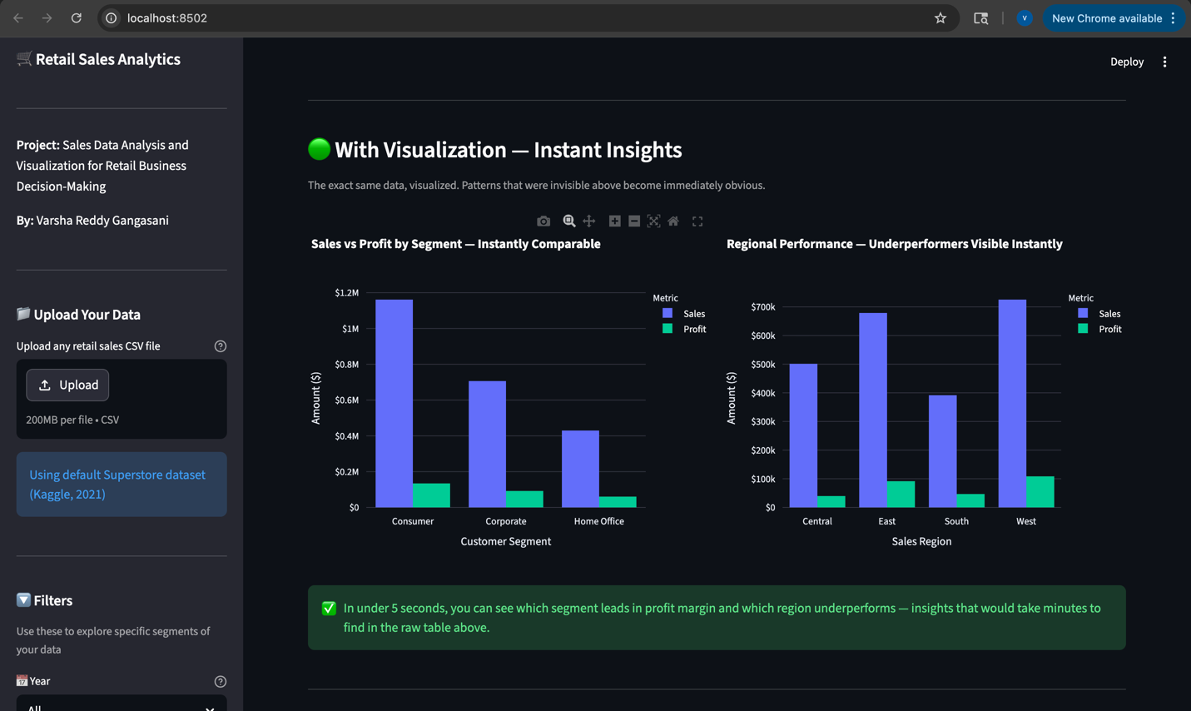
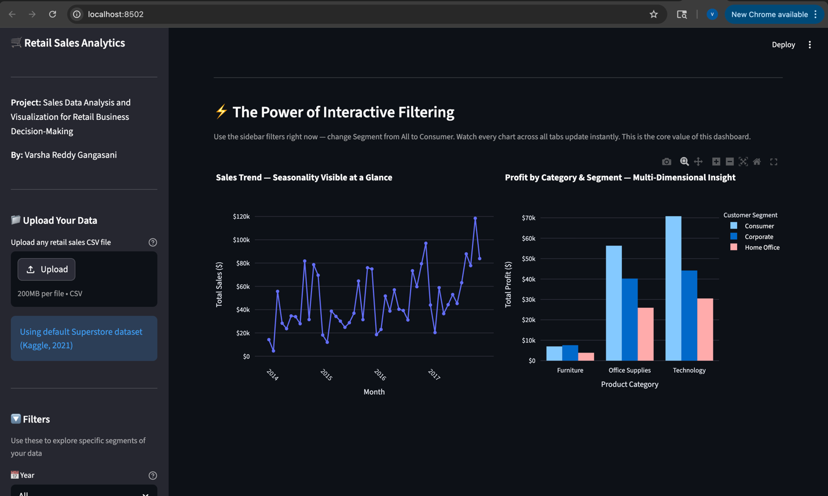
Figure 9: Streamlit App — Visualization Impact Tab
Tab 6 — Recommendations: Generated automated, data-driven business recommendations from the current filtered dataset, covering the top revenue segment, most profitable segment, Champion customers, At-Risk customers, and discount policy risks.
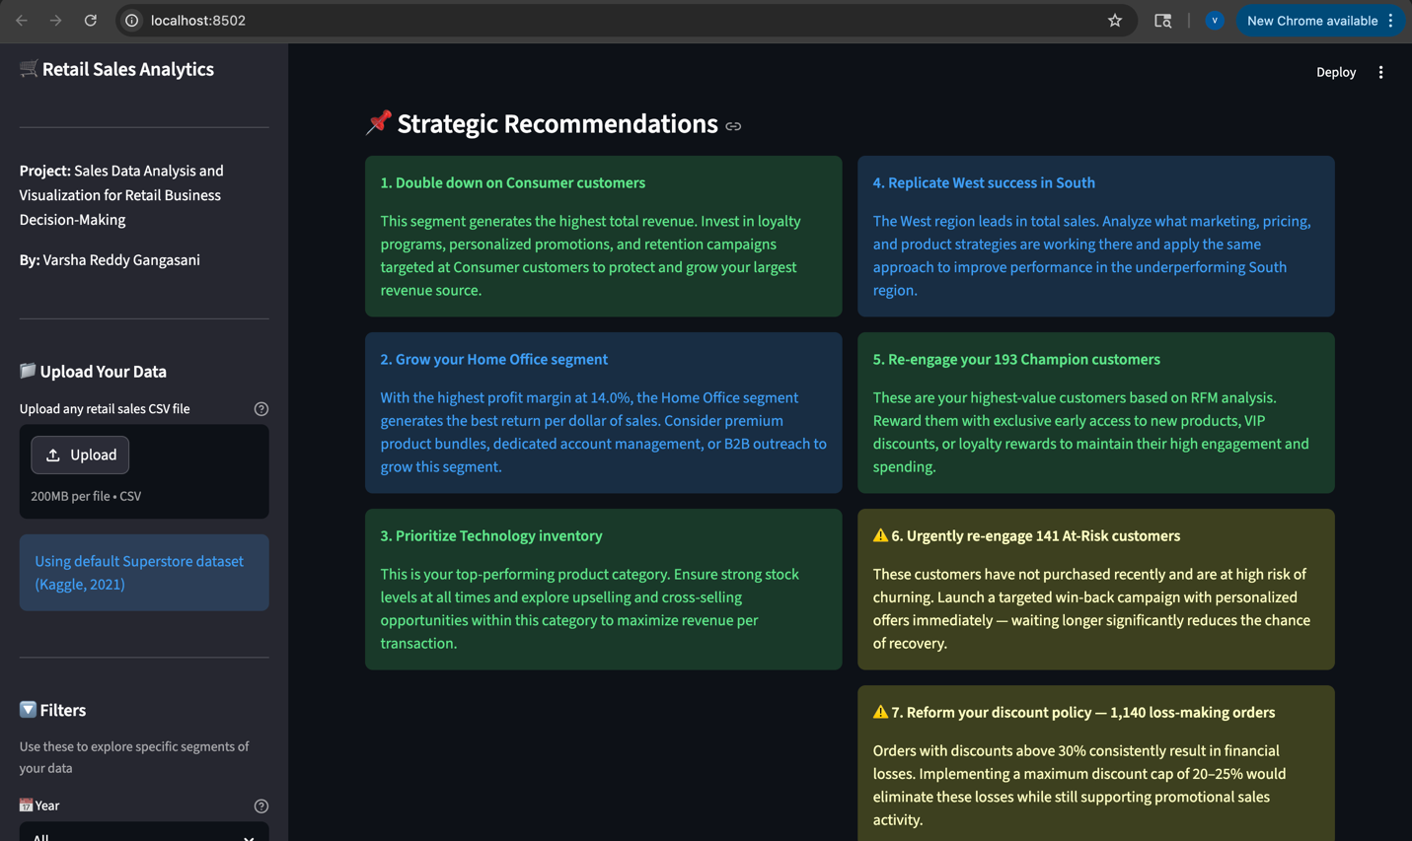
Figure 10: Streamlit App — Recommendations Tab

3.5 Power BI Dashboard
A supplementary Power BI dashboard was developed using Power BI Web (app.powerbi.com) to provide professional-grade visualizations suitable for inclusion in executive reports. Power BI was selected due to its wide adoption in enterprise business intelligence contexts and its capability to produce publication-quality interactive dashboards from CSV data sources [6]
The dashboard included four KPI cards (Total Sales, Total Orders, Total Customers, Total Profit), a clustered bar chart of Sales by Customer Segment, a line chart of Monthly Sales and Profit Trends, a donut chart of Sales by Region, a column chart of Profit by Category, and interactive slicers for Year, Segment, and Region.
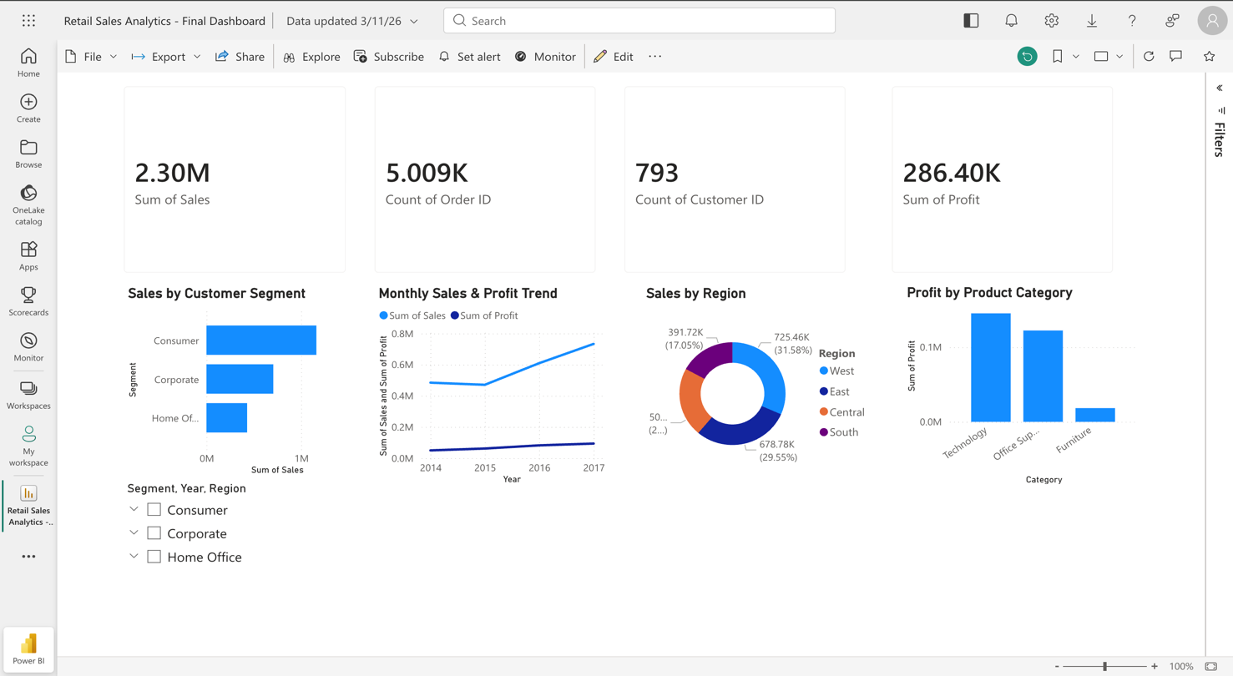
Figure 11: Power BI Dashboard — Professional Executive Reporting Layer

3.6 Technology Stack
Figure 4 below summarizes the complete technology stack deployed in this project, including each tool's role and version.

Figure 4: Technology Stack Deployed in This Project
Tool / Platform | Role in Project | Version
Python 3.11 | Core programming language for all data processing and analysis | 3.11 (Mac)
Streamlit | Web framework converting Python scripts into interactive prototype | v1.50.0
Pandas | Data loading, cleaning, transformation, and aggregation | v2.3.3
Plotly Express | All interactive charts and visualizations inside Streamlit | v6.5.2
Statsmodels | OLS regression for trendlines in discount/profit scatter plots | Latest
Power BI Web | Professional BI dashboard for executive-level reporting | app.powerbi.com
VS Code | Primary code editor and development environment | Latest
Kaggle | Source platform for the Superstore Sales Dataset | Public dataset
Figure 4: Full Technology Stack — Tools, Roles, and Versions

4. Results and Discussion

4.1 Summary of Findings
A total of 9,994 retail sales transactions were analyzed, spanning January 2014 to December 2017 across four US regions, three product categories, 17 sub-categories, and 793 unique customers across three business segments. Total revenue across the full dataset amounted to $2,297,201, with a total profit of $286,397, representing an overall profit margin of approximately 12.5%. These summary statistics are consistent with typical retail dataset characteristics described in applied analytics literature [1]

Total Revenue | Total Profit | Profit Margin | Total Customers
$2,297,201 | $286,397 | 12.5% | 793
Total Orders | Product Categories | Regions | Years Analyzed
5,009 | 3 (17 sub-categories) | 4 (E,W,C,S) | 2014 – 2017
Table 0: Full Dataset Key Performance Indicators

4.2 Explanation of Results — Customer Segmentation (RQ1 & RQ3)
The first and third research questions examined how customer segmentation impacts sales performance and how sales metrics vary across segments. Analysis of three predefined customer segments revealed considerable differences in both revenue contribution and profitability, consistent with prior research demonstrating that customer segment characteristics strongly influence retail financial outcomes [1]
Consumer customers contributed 50.5% ($1,161,401) of total retail revenue, Corporate customers contributed 30.7% ($706,146), and Home Office customers contributed 18.7% ($429,653). When profitability was considered alongside revenue, a contrasting trend emerged — Home Office customers achieved the highest profit margin at 14.0%, followed by Corporate at 13.0% and Consumer at 11.6%.

Segment | Total Sales | Total Profit | Profit Margin | Orders | Customers
Consumer | $1,161,401 | $134,119 | 11.6% | 2,586 | 409
Corporate | $706,146 | $91,979 | 13.0% | 1,514 | 236
Home Office | $429,653 | $60,299 | 14.0% | 909 | 148
Table 1: Sales and Profit Metrics by Customer Segment

Segment | Avg Orders / Customer | Avg Order Value | Profit Margin
Consumer | 6.3 | $224 | 11.6%
Corporate | 6.4 | $234 | 13.0%
Home Office | 6.1 | $241 | 14.0%
Table 3: Purchase Frequency and Order Value by Segment

4.3 Comparative Analysis — RFM Behavioral Segmentation (RQ2)
The second research question asked what distinct customer segments could be identified from retail sales data. RFM analysis was applied to the 793 unique customers to identify behavioral segments based on actual purchasing patterns. This behavioral segmentation approach is supported by Fader et al. (2005), who demonstrated that RFM scoring reliably produces distinct and actionable customer groups from transactional retail data [3]
The analysis produced five distinct RFM segments, each with clear behavioral and financial characteristics as summarized in Table 2 below.

RFM Segment | Customers | Avg Recency | Avg Frequency | Avg Monetary | Share
Champions | 193 | Low | High | $4,900+ | 24.3%
Loyal Customers | 222 | Medium | Med-High | $3,500+ | 28.0%
Potential Loyalists | 183 | Medium | Medium | $2,000+ | 23.1%
At Risk | 141 | High | Low-Med | $1,000+ | 17.8%
Lost Customers | 54 | Very High | Low | Very Low | 6.9%
Table 2: RFM Behavioral Segmentation Summary

4.4 Sales Trend and Discount Analysis
Monthly sales trend analysis revealed consistent revenue growth over the four-year period from 2014 to 2017, with notable seasonal peaks in Q4 each year, particularly in November and December. This seasonal pattern is consistent with typical retail demand behavior driven by holiday shopping, as documented in retail forecasting literature [7]
Analysis of sub-category performance identified Phones, Chairs, and Storage as the top three revenue-generating sub-categories. Conversely, Tables recorded negative total profit, representing the most significant loss-making sub-category.

Top Revenue Sub-Categories | Loss-Making Sub-Category | Seasonal Peak Period
1. Phones | Tables (negative total profit) | November & December (Q4)
2. Chairs | Pricing review recommended | Consistent Q4 peak every year
3. Storage | Inventory optimization needed | 2014–2017 upward trend
Table 4: Sub-Category Performance Summary

A critical finding emerged from the analysis of discount rates and their impact on profitability. The scatter plot in the prototype revealed a clear negative correlation between discount levels and average profit. This relationship between excessive discounting and profitability erosion is consistent with findings reported by Anderson and Simester (2003), who demonstrated that aggressive discount strategies consistently reduce per-unit profit margins in retail settings [8]
Orders with discounts above 30% consistently resulted in negative profit, accounting for 1,140 orders in the dataset. This represents a quantifiable and directly addressable risk to business profitability.

4.5 Addressing Research Questions
All four research questions were addressed through the prototype and the analysis conducted in this study. RQ1 was answered through the customer segmentation analysis demonstrating that segment choice significantly impacts both revenue volume and profit margin. RQ2 was answered through the RFM analysis that identified five distinct behavioral segments beyond the standard business categories. RQ3 was answered through the metrics comparison table showing that while purchase frequency is consistent across segments, average order value and profit margin differ meaningfully. RQ4, the main research question, was answered through the Visualization Impact tab which directly demonstrated that visual representations of the same data reduced pattern-detection time from minutes to seconds.

4.6 Implications and Significance
The findings of this study have important practical implications for retail businesses. The demonstration that Home Office customers achieve the highest profit margins despite having the fewest customers suggests that acquisition strategies should not focus solely on volume. The identification of 141 At-Risk customers through RFM analysis provides an immediately actionable target list for re-engagement campaigns. The finding that 1,140 orders with discounts above 30% resulted in losses provides a clear, quantifiable basis for discount policy reform [9]
From a theoretical perspective, this project contributes to the literature by demonstrating the feasibility of combining predefined segment analysis with behavioral RFM segmentation within a single interactive interface — a combination that prior literature identified as an underexplored area.

5. Conclusion and Future Work
The objective of this project was to create a functioning and reusable analytics prototype for retail sales, and this objective was successfully achieved. The Streamlit-based web application allowed any retail organization to upload their sales data and automatically receive analysis across six analytical dimensions: overview metrics, customer segmentation, sales trends, RFM behavioral segmentation, visualization impact demonstration, and automated business recommendations.
The analysis of the Superstore Sales Dataset revealed several significant findings. Customer segmentation had a measurable impact on sales performance, with the Consumer segment leading in revenue but the Home Office segment achieving the highest profit margin. RFM analysis identified five distinct behavioral customer groups, with 193 Champion customers representing the most valuable retention target and 141 At-Risk customers requiring immediate re-engagement. The discount analysis revealed that 1,140 orders with discounts above 30% resulted in losses, representing a quantifiable risk to business profitability.
Most significantly, the Visualization Impact tab provided a direct demonstration of how data visualization transforms raw retail data into clear, interpretable, and actionable business intelligence, answering the study's main research question. The combination of the Streamlit prototype and the Power BI dashboard delivered both an interactive analytical tool and a professional reporting layer, meeting the full scope of the project requirements.

5.1 Limitations
Several limitations should be acknowledged. First, the Superstore dataset, while comprehensive, represents a simulated retail environment and may not capture the full complexity of real-world operations. Second, the RFM segmentation used quartile-based scoring, a simplified approach compared to machine learning clustering methods such as K-Means. Third, the prototype ran locally and had not been deployed to a public web server, limiting external accessibility. Finally, the Power BI dashboard required manual data refresh and did not support real-time updates.
Several directions for future development would significantly enhance the prototype. First, the integration of K-Means clustering would allow the system to identify data-driven segments beyond predefined categories. Second, a sales forecasting module using ARIMA or Facebook Prophet would extend the tool from descriptive to predictive analytics. Third, deploying the application to Streamlit Community Cloud would make the prototype accessible to any user with a web browser.

References
[1] Ngai, E. W. T., Xiu, L., & Chau, D. C. K. (2009). Application of data mining techniques in customer relationship management: A literature review and classification. Expert Systems with Applications, 36(2), 2592–2602. https://doi.org/10.1016/j.eswa.2008.02.021

[2] Hosseini, S. M. S., Maleki, A., & Gholamian, M. R. (2010). Cluster analysis using data mining approach to develop CRM methodology to assess the customer loyalty. Expert Systems with Applications, 37(7), 5259–5264. https://doi.org/10.1016/j.eswa.2009.12.070

[3] Fader, P. S., Hardie, B. G. S., & Lee, K. L. (2005). RFM and CLV: Using iso-value curves for customer base analysis. Journal of Marketing Research, 42(4), 415–430. https://doi.org/10.1509/jmkr.2005.42.4.415

[4] Wei, J.-T., Lin, S.-Y., & Wu, H.-H. (2010). A review of the application of RFM model. African Journal of Business Management, 4(19), 4199–4206.

[5] Few, S. (2009). Now You See It: Simple Visualization Techniques for Quantitative Analysis. Analytics Press.

[6] Eckerson, W. W. (2010). Performance Dashboards: Measuring, Monitoring, and Managing Your Business (2nd ed.). John Wiley & Sons.

[7] Hyndman, R. J., & Athanasopoulos, G. (2021). Forecasting: Principles and Practice (3rd ed.). OTexts. https://otexts.com/fpp3/

[8] Anderson, E. T., & Simester, D. I. (2003). Effects of $9 price endings on retail sales: Evidence from field experiments. Quantitative Marketing and Economics, 1(1), 93–110. https://doi.org/10.1023/A:1023581927405

[9] Hevner, A. R., March, S. T., Park, J., & Ram, S. (2004). Design science in information systems research. MIS Quarterly, 28(1), 75–105. https://doi.org/10.2307/25148625

[10] Vivek, R. (2021). Superstore Dataset [Data set]. Kaggle. https://www.kaggle.com/datasets/vivek468/superstore-dataset-final

